**DAILY ONLINE ACTIVITIES SUMMARY**

|  |  |  |  |  |  |  |  |  |
| --- | --- | --- | --- | --- | --- | --- | --- | --- |
| **Date:** | **03-07-2020** | | | | | **Name:** | **Deeksha D Poojary** | |
| **Sem & Sec** | **VIII Semester & A Section** | | | | | **USN:** | **4AL16CS026** | |
| **Online Test Summary** | | | | | | | | |
| **Subject** | | **-** | | | | | | |
| **Max. Marks** | | **-** | | **Score** | | | **-** | |
| **Certification Course Summary** | | | | | | | | |
| **Course** | **Introduction to Amazon Elastic Compute Cloud (EC2)** | | | | | | | |
| **Certificate Provider** | | | **Amazon Web Service** | | **Duration** | | | **10 minutes** |
| **Coding Challenges** | | | | | | | | |
| **Problem Statement: Write a program to find simple interest** | | | | | | | | |
| **Status: COMPLETED** | | | | | | | | |
| **Uploaded the report in Github** | | | | | **YES** | | | |
| **If yes Repository name** | | | | | **deekshapoojari** | | | |
| **Uploaded the report in slack** | | | | | **YES** | | | |

Online Test Details:

NIL

Certification Course 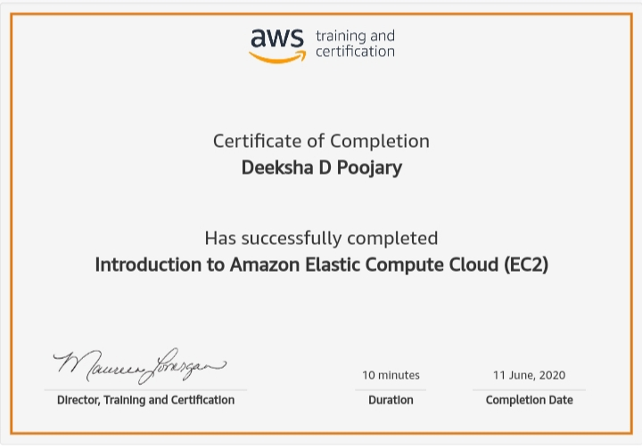Coding Challenges Details:

|  |
| --- |
|  |
|  |
|  |
|  |
|  |
|  |
|  |
|  |
|  |
|  |
|  |
|  |
|  |
|  |
|  |
|  |
|  |
|  |
|  |
|  |
|  |
|  |
|  |
|  |
|  |
|  |
|  |
|  |
|  |
|  |
|  |
|  |
|  |
|  |
|  |
|  |
|  |
|  |
|  |
|  |
|  |
|  |
|  |
|  |
|  |
|  |
|  |
|  |
|  |
|  |
|  |
|  |
|  |
|  |

**Program1:**

|  |  |
| --- | --- |
|  |  |

#include<iostream>

#include <stdio.h>

using namespace std;

int main() {

   //principle amount

   float p = 5;

   //time

   float r = 4;

   //rate in years

   float t = 5;

   // Simple interest

   float SI = 0;

   SI =(p * t * r) / 100;

   printf("Simple Interest = %f ",SI);

   return 0;

}